Dear {{ ClientSalutation }},
We have recently changed our approach to the way we send documents to our clients. Rather than attaching a document directly to an email, we will now share links to your documents and client folders. This new process is safer, ensuring your documents remain secure, private and only accessed by those intended.
To ensure that this change is as seamless as possible, we would like to step you through the change:
- You will still receive an email from us as you always have. The change being there will no longer be an attached document but rather a link inside of the email body which directs you to the document in your Collaborate site.
- Click on the link.
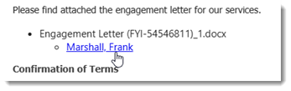
- Once you click on the link, you are prompted to log in to display the document.
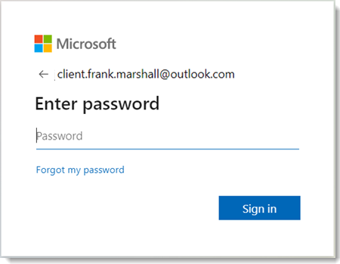
- The relevant users and contacts will also receive an email containing links to your client folders, where you can display all documents shared from our practice.
We believe that given the increasing need for vigilance with cyber security, this measure has our client’s best interests front of mind.
Access has been provided to the recipients of this email. If you have additional contacts that you wish to allow to access your portal, please reply to this email with their email address and whether you wish to give them full access to shared documents or nominate which documents you wish to share with them.
Should you have any further questions or experience issues that cannot be resolved from the information above, please contact our office.
Kind regards,
{{ AuthorName }}
{{ AuthorRole }}

