Dear {{ ClientSalutation }},

We will be sending you an email soon, to give you access to your secure client folders. This will provide you with quick access to all documents we share with you. An email will be sent specifically to you and to any other users who require access. This ensures your documents remain secure, private, and only accessed by those intended.

If you have additional contacts that you wish to allow to access your portal, please reply to this email with their email address and whether you wish to give them full access to shared documents or nominate which documents you wish to share with them.

To ensure that this is as seamless as possible, we would like to step you through what you do to access the shared folders.

1. You will still receive an email from us with links to **direct you to your dedicated Collaborate site**.  
     
   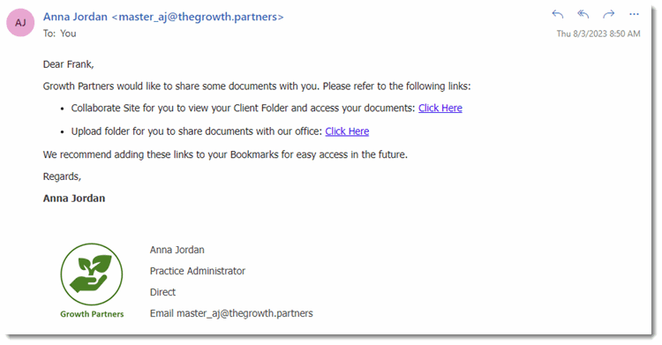
2. Click on the **Click here** link in the email to access the Collaborate Site and your Upload Folder.
3. Once you click on the link, you will be prompted to log in to display the folders.
4. Bookmark the Collaborate site for easy access.

Once you have logged in, the folders in your Collaborate site will display, similar to the images below.

**Your Shared Folders**

Your shared folder and sub-folders contain all documents that have been shared with you.

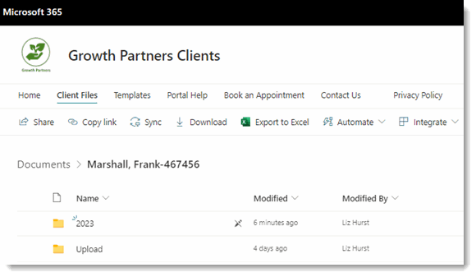

You can open any of the sub-folders to see the documents that we have shared with you.

**Your Upload Folder**

Within the shared folders you will also see the **Upload** folder. This provides an alternate way for you to send documents to our practice instead of sending documents by email. You can save or drag your files directly to the Upload folder. When you open the **Upload** folder, it looks like this:

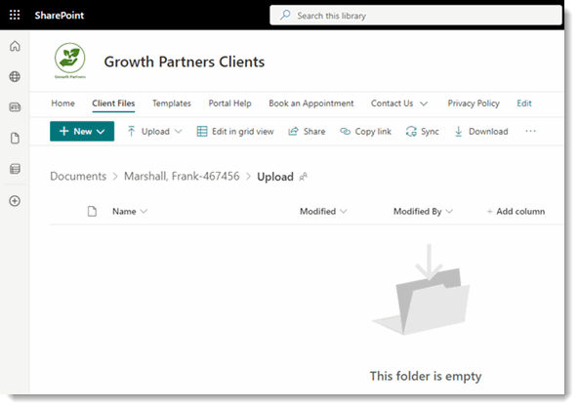

**Uploading Files**   
You can drag files to the **Upload** Folder or use the **Upload** function to upload selected files or folders. There is a 500MB limit per file that can be added to the Upload Folder.

Once we have received your files, they will be removed from the Upload Folder.

**If you lose the link**  
If you lose the link to your folder or your Collaborate site, let us know and we can resend it to you.

Should you have any further questions or experience issues that cannot be resolved from the information above, please contact our office.

Kind regards,

{{ AuthorName }}

{{ AuthorRole }}